Take Note! OneNote Solutions for Students with Learning Disabilities
CCDI, May 2009
Microsoft Office OneNote Guided Activity
Janet Rivera, Sherri Parkins
Seneca College of Applied Arts and Technology

Getting Started with OneNote
Section Tabs
Menu Bar
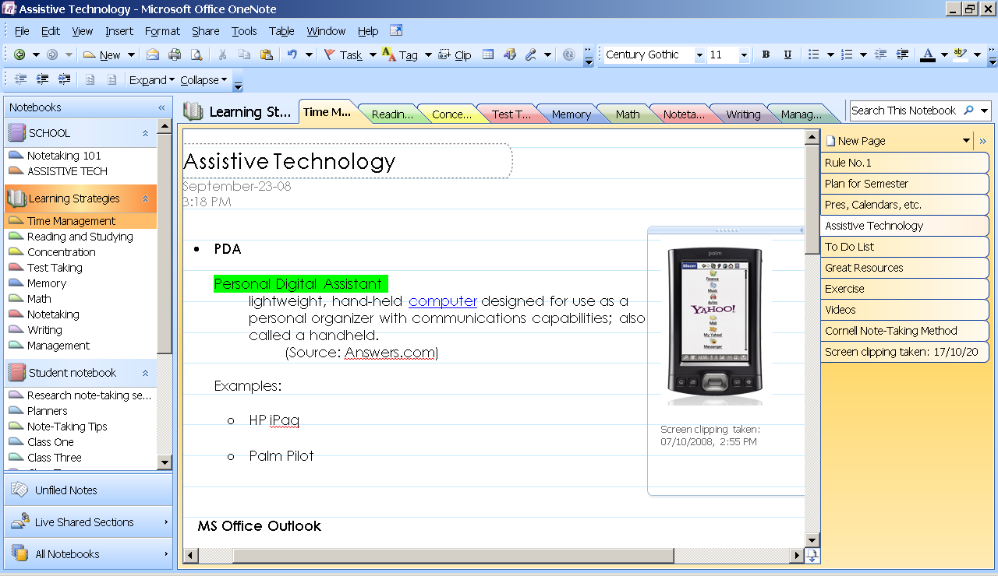
Toolbar
Notebooks
Page Tab

As you write information on OneNote, it is automatically saved. There is no Save button in OneNote. Information is automatically saved in folders or “notebooks.” Folders are stored at My Documents/OneNote Notebooks.
Each notebook is divided into sections, and sections into pages. Think of it as your binder or paper notebook.


Pages

Sections
Creating Digital Notebook
- Click the Start menu
- Select Programs
- Select Microsoft Office 2007
- Open Microsoft Office OneNote 2007
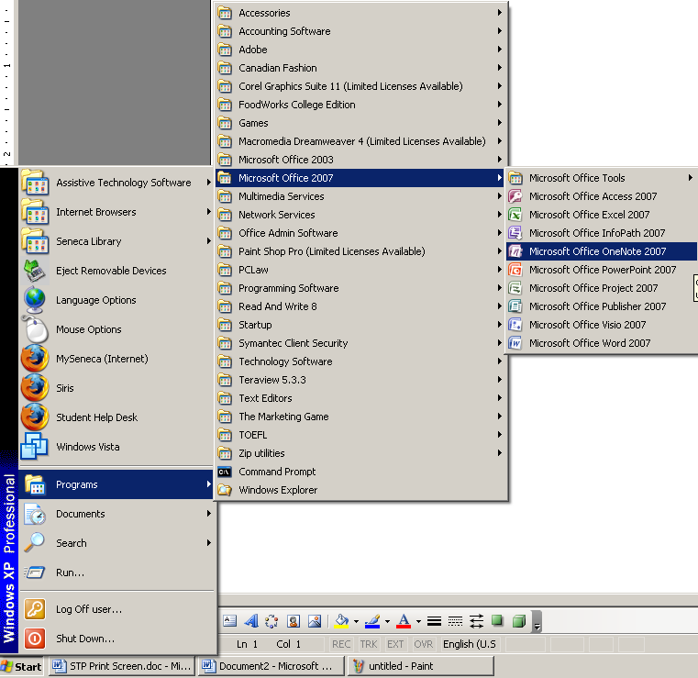
- Go to File menu, select New and then click Notebook
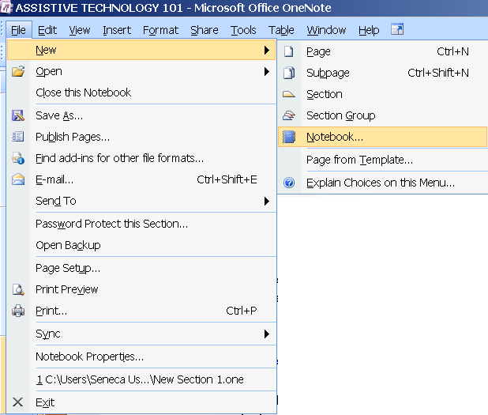

- Type a name for your Notebook. For example PSY125, EAC149, etc.
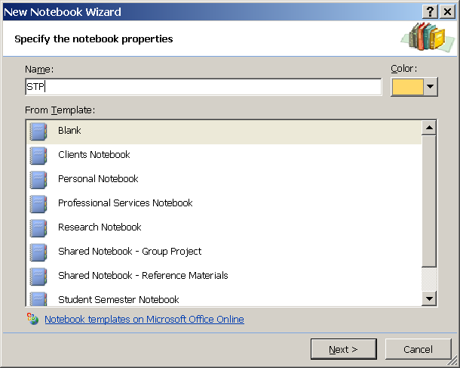
Click the Next button
- The next screen pops up this question “Who will use this notebook?”
  - Select the option “I will use it on this computer”
  - Click Next button
- Confirm Notebook Location and click the Create button
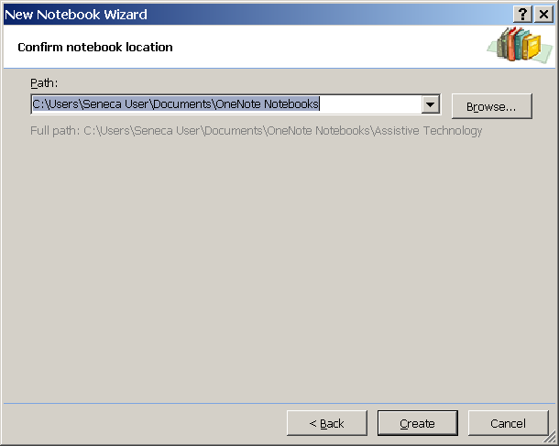
- Double-click on the tab and rename it as “Week 1,” section or chapter name

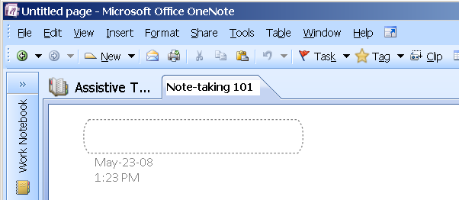

- To create new section or folder for each of your course, click on File menu, select New and select Section. Try to set up sections for weeks 2-5
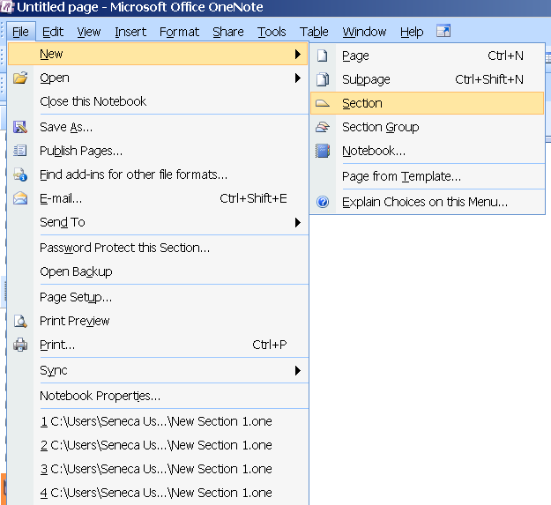
- Click the File menu, select New and select “Page from Template”
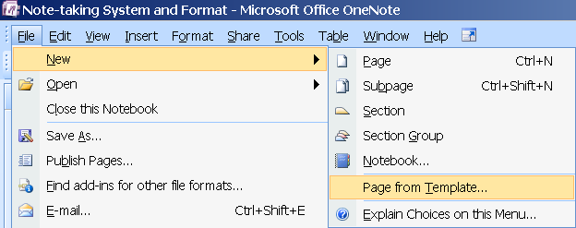
- The Templates window appears at right side of your screen. You should see five (5) different categories – Academic, Blank, Business, Decorative and Planners.

Expand the Academic folder by clicking the plus (+) sign beside it
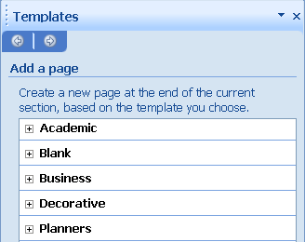
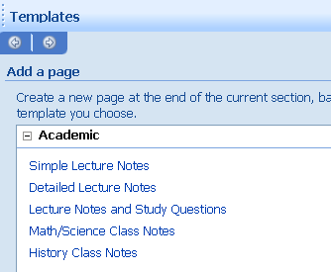
Select the template “Lecture Notes and Study Questions”
- Provide a title for your topic or lecture.
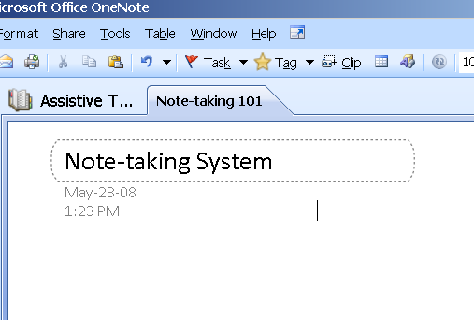

- Fill in all the relevant information such as Homework, Today’s Topic, Important Points, Lecture Topics and Summary
For example,
Today’s Topic: <Provide a title for today’s lecture>
Announcements: <Any quizzes, exams, etc. that you want to announce?>
Homework: <List homework for your recent class>
Lecture Topics: <Come up with 3 main points from your recent lecture>
Summary…Etc.

When you type anywhere on the document or page, the notes are automatically saved and displayed on note containers. You can select a container and drag it anywhere within the page.
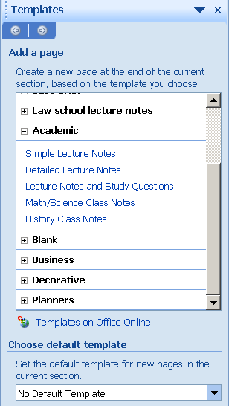

- Click File from the main menu and Select New from the list

- Select Page from Template

- Template Pane appears at the right side of your window

- Click the Templates on Office Online link at the bottom

- You will be directed to the Microsoft Office Online search

- Type a key word on the Templates search field like “legal”, etc.

- Explore the different types of templates for Word, PowerPoint, Access, etc.

OneNote as a Research Tool
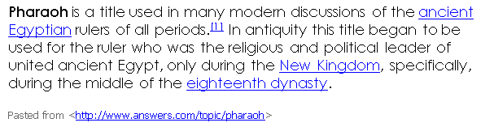
You can select and capture sections of your screen and include it as part of the OneNote document or page. This is most useful when you are using OneNote as a research tool.
- Open the internet
- Highlight a text or section of the web page
- Copy the text
- Paste the text to OneNote page
- Observe that the website or URL was automatically pasted together with the text.
- You can also send the contents of a webpage to OneNote by pressing the OneNote icon located on the Internet Explorer tool bar:
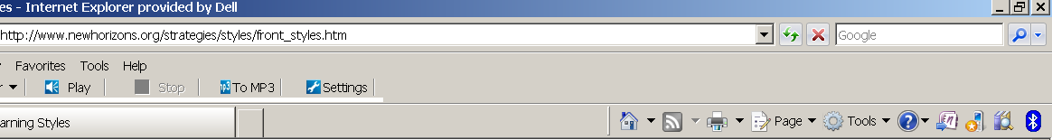
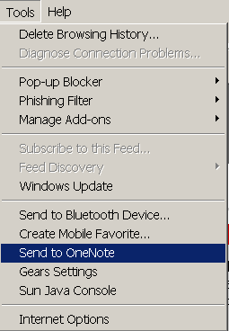
- If you cannot locate this icon, you can go to Tools menu and
Select; Send to OneNote

- The aforementioned steps automatically create a notes page which displays the contents of the web page together with the URL. The new page becomes part of the Unfiled Notes. You can move the page by clicking the Unfiled Notes tab and using the mouse to drag and drop it to the appropriate notebook.
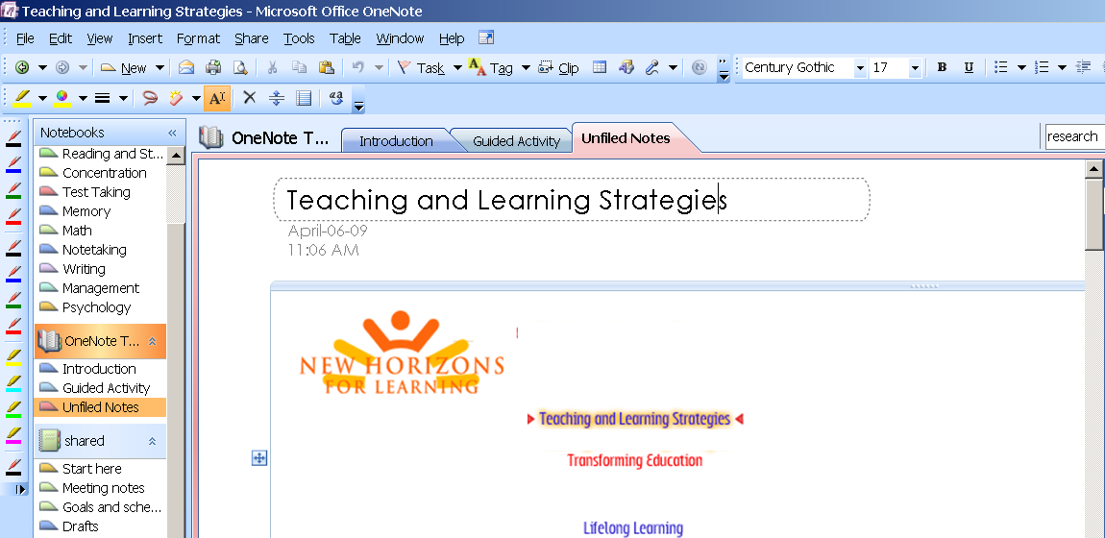

Active Note Taking Using Tags, Recording and Other Features
Tagging Notes
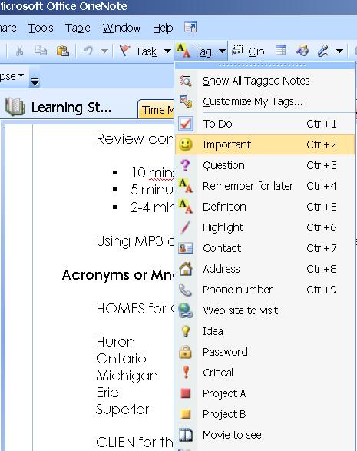
- Put your cursor beside the text you want to tag
Click the Tag button on the task bar
Select the appropriate tag:
- Important
- Question
- Definition
- To Do

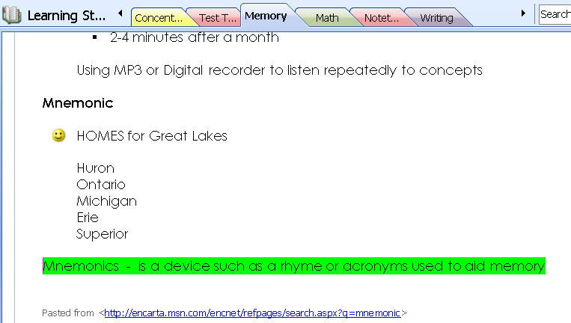
Try this: Type a term and a short definition.
Label it by using the Definition tag. Refer to instructions above on how to access the different tags. Notice that OneNote highlighted your definition in Green! You can customize your own tags and highlight information based on color-coding, e.g. headings and subheadings in blue, questions in pink, etc.

Basic Recording Features
- Plug in your headset or microphone.
- On the toolbar, locate the “Record Audio Only” button and click on it.
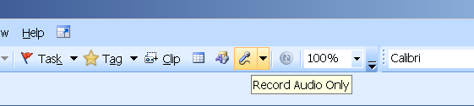
- The Audio and Video Recording bar appears
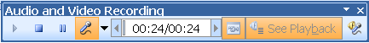
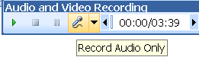
- Click on the microphone icon and start your voice recording. Note that the timer begins to move…

- Press STOP button to stop recording
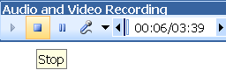
- Press Play button to listen to your recordings

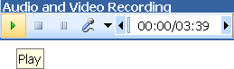

Synchronizing Notes with Audio Recording

You can synchronize and reference the audio file using the words typed or the keystrokes used while recording the lecture.
- Follow the same instructions mentioned above to open the audio recording tool bar and record your class.
- Type a key word or phrase while you are recording. As you are typing the key words, OneNote synchronizes those texts to your voice or video recording.
Reviewing Notes by Listening

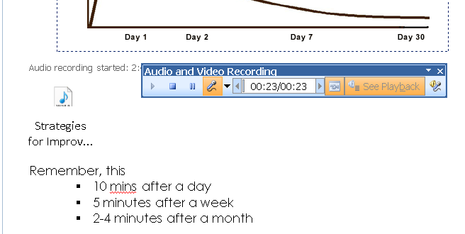
- If you wish to listen to the recording associated with the key words you have typed, hover your mouse on those words and OneNote replays the audio recorded when the notes were taken.

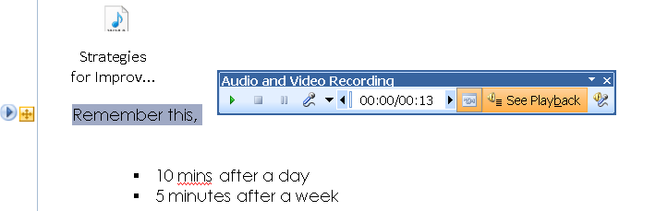
- Hover the mouse on key words or cues like “remember this,” the Play icon appears beside your key word. Click the Play icon. The recording tool bar comes out and plays back the audio when you typed or created the keystroke (e.g. typing, highlighting, tagging, etc.).

Play icon

Synchronizing Voice Recordings with a PowerPoint Presentation

By using PowerPoint slides and the OneNote recording and synchronizing features, students are able to focus on reviewing critical sections of the lecture. The notes typed and tags/highlights created by students are digitally link to the sound recorded at the same time.

When the student reviews the audio recordings, it will bring up the section or part of the lecture recorded at the time that the student wrote the note or highlighted the text.

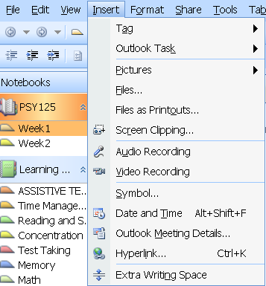
- Open your PowerPoint lectures slides from OneNote

- Click “Insert” from the main menu

- Select “Files as Printouts”

- “Choose Document to Insert” window appears

- Locate and select your PowerPoint file
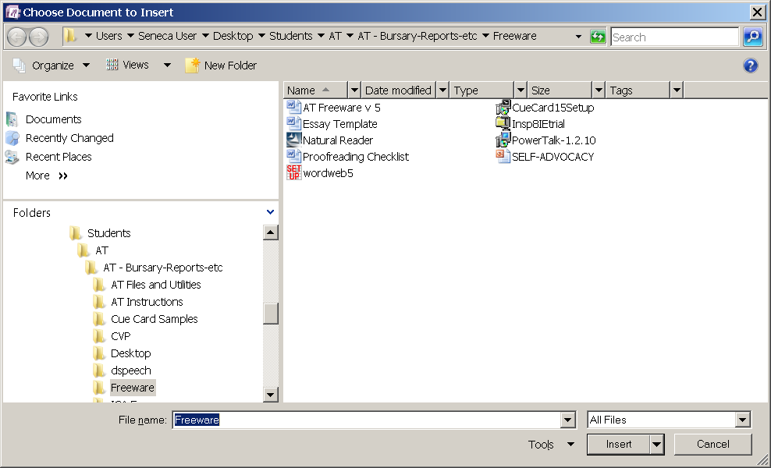

Click the Insert button

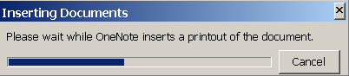
OneNote issues a message “Inserting Documents….” This message disappears and your PowerPoint is automatically opened in OneNote

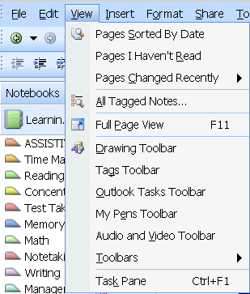
- To get a full view of the PowerPoint slides:

Click View from the main menu

Select Full Page View

While you are recording your lecture, OneNote will mark the recordings based on your keystrokes, tags, highlights or any text that you type on your PowerPoint slides.

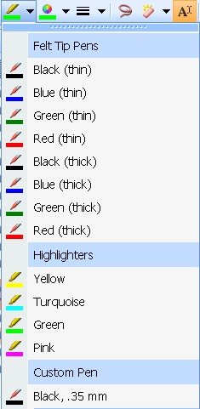
- To use the highlighters, right click on any part of your tool bar and select Writing Tools. This will open up the Pens.

Choose a color by clicking the drop down arrow
to expand the list and pick a color for highlighting important points.

- Open the recording toolbar using the steps outlined in #18

- Click Record button to begin recording your lecture

- Click, highlight, tag or type a text beside the key term on your slide as you are recording its definition.

This process synchronizes your keystrokes with the voice recording, making it easier for your students to listen and review their notes.

- Hover the mouse on the highlighted, tagged or annotated text on your slide. You should see the Play back button. Click the button. This brings up the section or part of the lecture recorded at the time that the student wrote the note or highlighted a text.

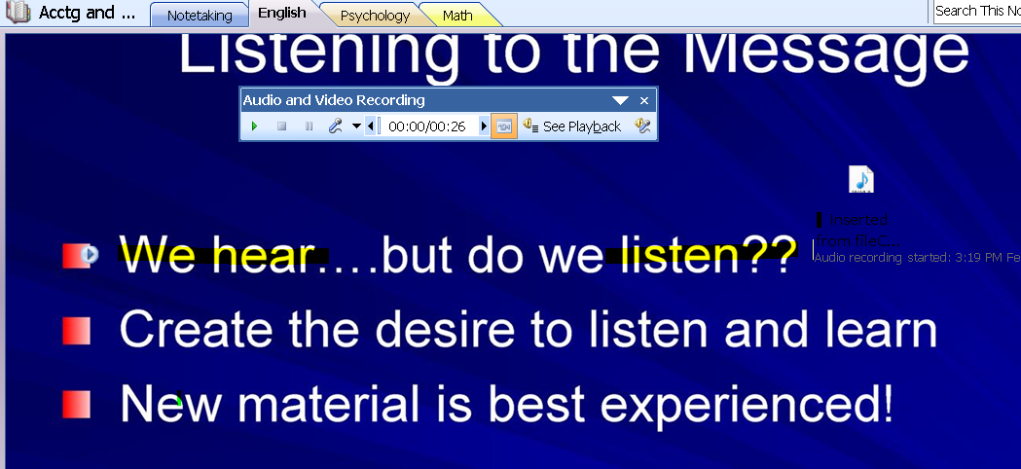

Using OneNote for Time Management and Planning

- Click the File menu, select New and select “Page from Template”
- The Templates window appears at right side of your screen. You should see five (5) different categories – Academic, Blank, Business, Decorative and Planners.
Expand the Planners folder by clicking the plus (+) sign beside it

Select Prioritized To Do List
Select Prioritized To Do List
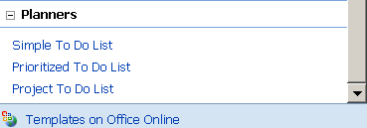

To Do List template

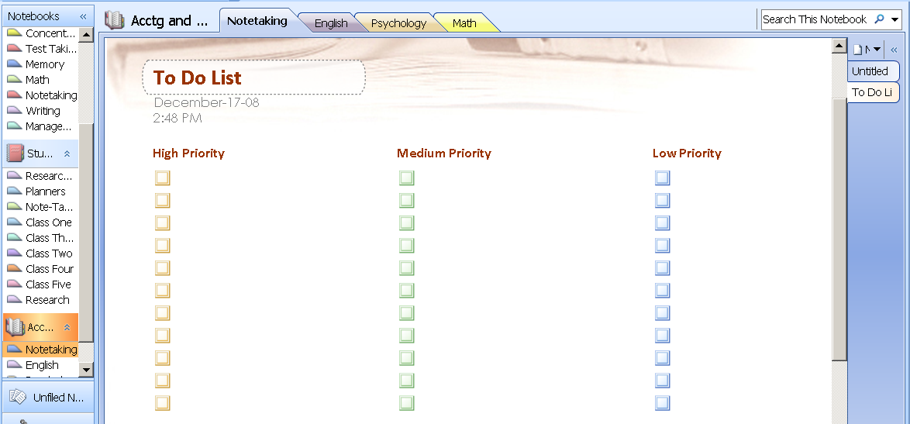

- Start typing your course requirements (e.g. assignments, homework, assigned readings, etc.) and prioritize them using the categories High, Medium and Low.
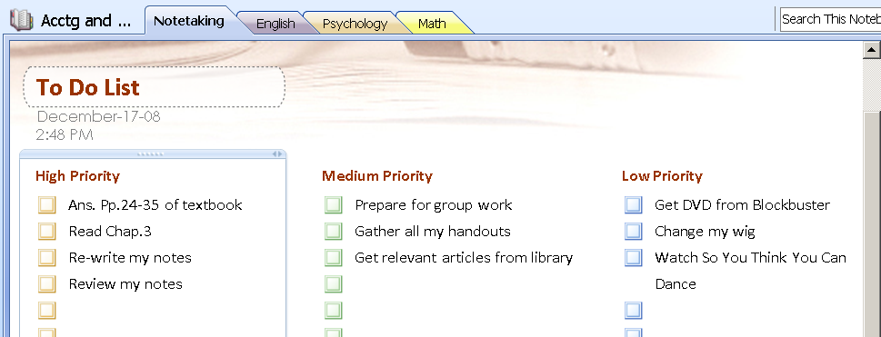

- Once you have completed the task or activity, click the check box!

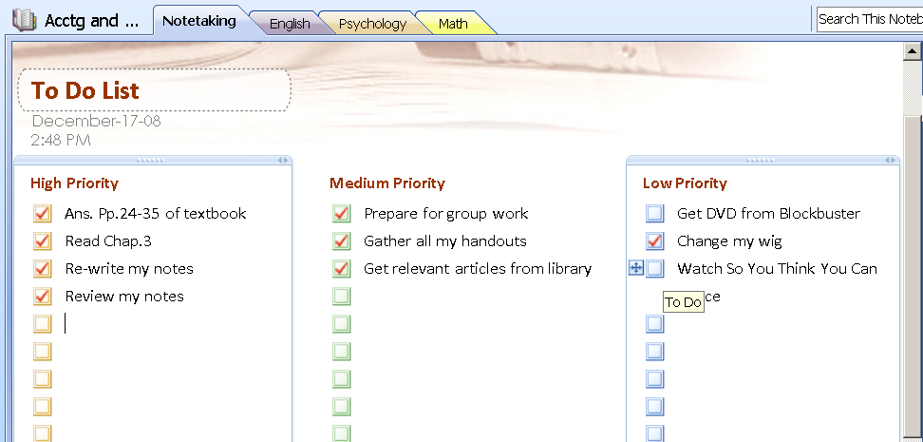

If you wish to set deadlines, you can do so by going to the Task button on your tool bar.

- Click on the task or event
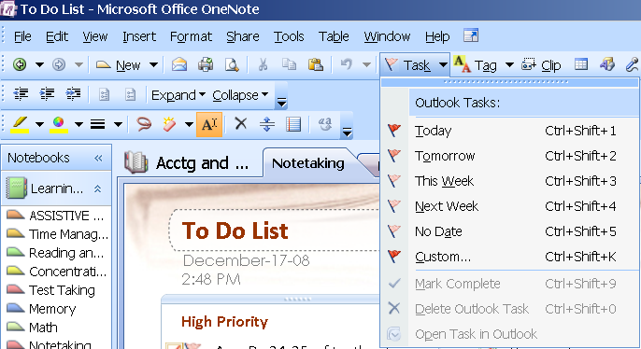

- Click the drop down arrow beside the Task button.

- Select from the list of dates, e.g. Today, This Week, Next Week or simply click Custom to set a specific date.

A red flag icon will be displayed right beside the task.

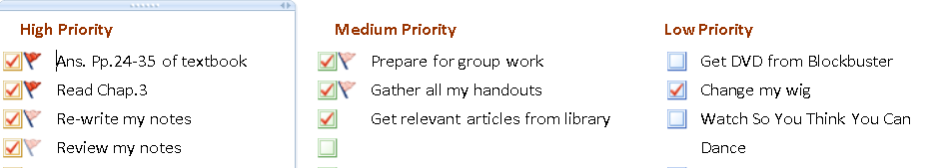

- If you point or hover your mouse on the task, it will display the due date set for the task.
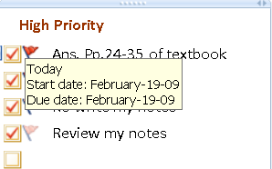

Inserting Files and Documents in OneNote page
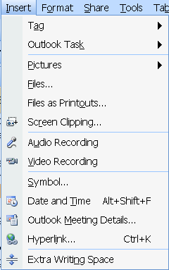
- Go to Insert menu on the toolbar
- Select Files

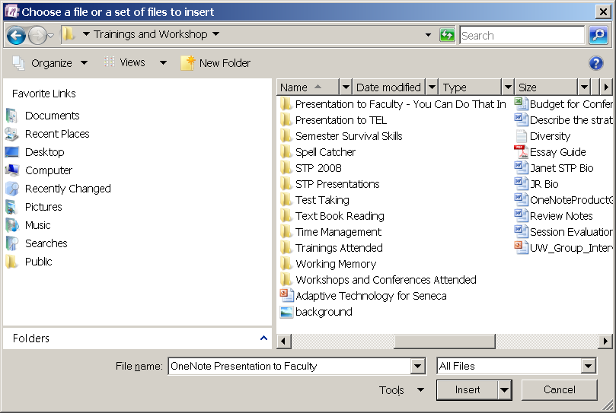
- Select and click the file that you want to insert from the list of folders

- Click the Insert button

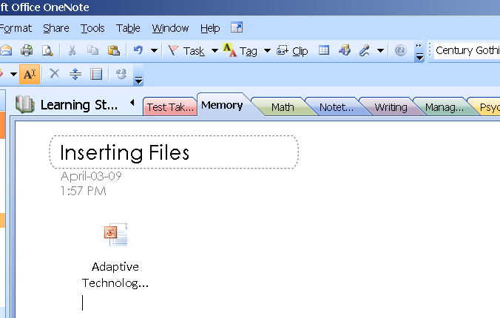
You will see your file pasted as icon on the OneNote page

- Double click the file icon to view it

Side Note to Capture Information
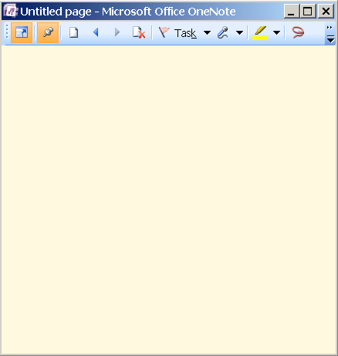
You can capture information while working on another application using the Side Note. This allows you to take notes while researching on the internet or while using other applications like PDF, Word, etc.
- Press CTRL+SHIFT+M
- The window becomes a smaller
version of OneNote that hovers on top of any active applications. Within this small window display you can type, highlight, copy and paste, record and access other features of OneNote. It can be compared to an electronic version of sticky notes.

- Press the pin icon to keep it in one place. Press it again to unpin the side note.
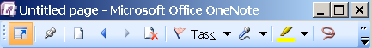
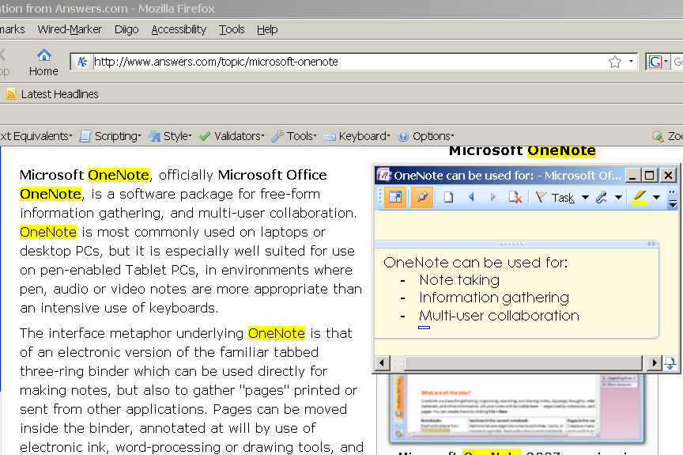
- Type to summarize or capture your thoughts on the side note. You can also copy and paste the information.
63. Click the Full Page View icon at the left top corner of the Side Note.
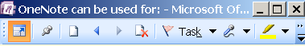

The OneNote window comes out. Maximize the window.
- The Side Note becomes part of the Unfiled Notes. You can move the page by clicking the Unfiled Notes tab and using the mouse to drag and drop it to the appropriate notebook.
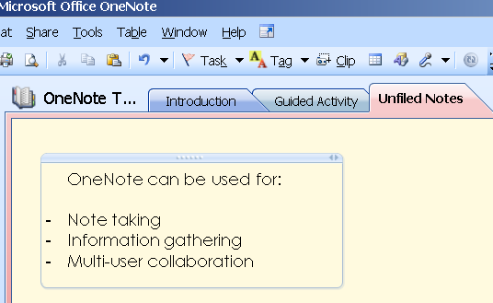

Live Sharing Sessions
Using OneNote live sharing session feature, multiple users can access, add, revise and make changes on lectures and notes at the same time. This feature not only allows users to share notes and make collaborative work but also let them update and share the changes online and real-time.
- Go to the section or page you wish to share
- Go to the toolbar and click Share
- Select Live Sharing Session
- Select Start Sharing Current Session
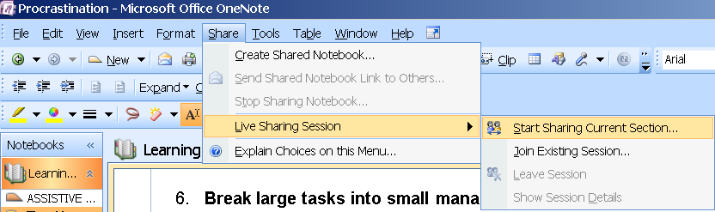

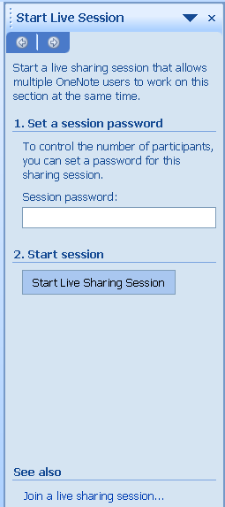

- Start Live Session pane appears at the right side of the screen
- Type a password under “1.Set a session password”
- Click the button “Start Live Sharing Session”

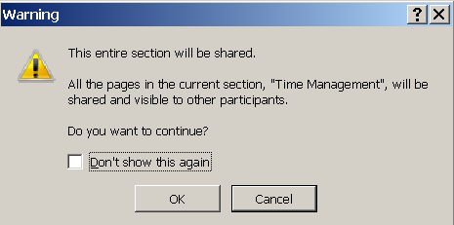
- A warning message dialog box pops out saying that the entire section will be shared.
Click the OK button.

- A message is displayed on the screen “A live sharing session is being started…”
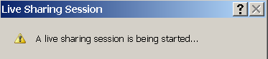
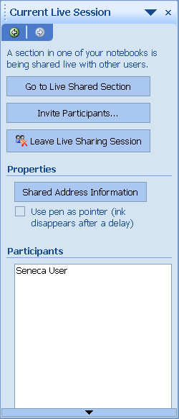
- Current Live Session pane is displayed at the right side of the screen.

Click Invite Participants button

- It automatically opens Microsoft Office Outlook email application and produces an email request. Since we are not using Outlook as an email system, you need to copy the contents of the email. Highlight all the text, do a right click and select Copy.
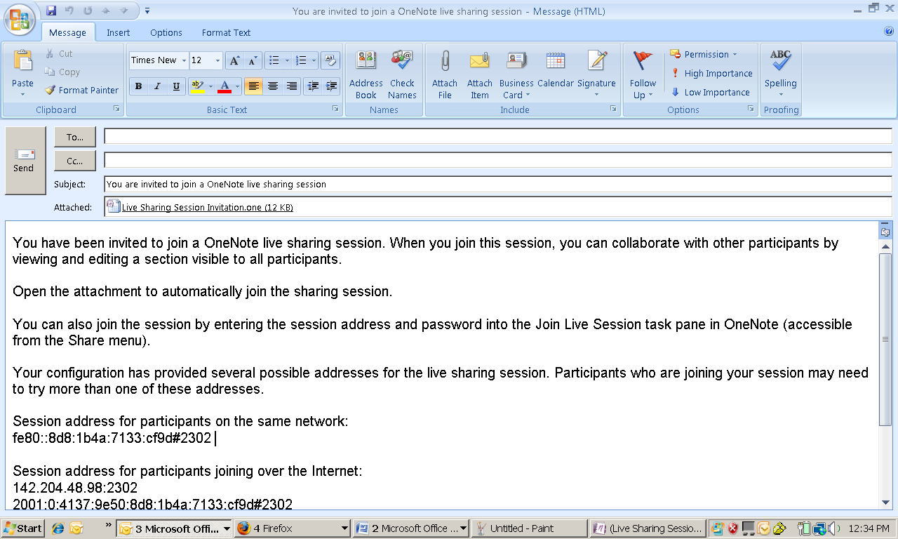
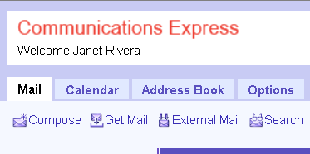
Open your Seneca email (Communication Express)
Click Compose

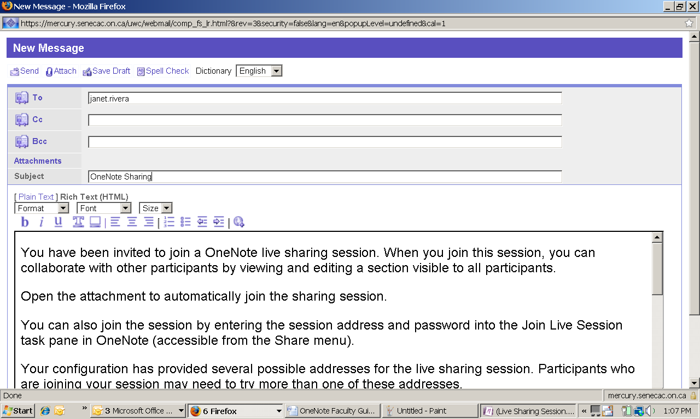
Type the email of your students or an emailing list if you wish to send it to all your students.

Type a subject, e.g. “Invitation to join a OneNote live sharing session”

Click Send

How to Join a Live Sharing Session in OneNote
- Go to your toolbar and select the Share menu
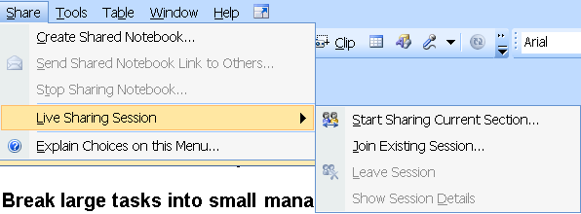
2. Click Live Sharing session
3. Select Join Existing Session

4. Open your Seneca email (Communication Express)
- Find and open the email with subject “You are invited to join OneNote live sharing session” or similar subject line
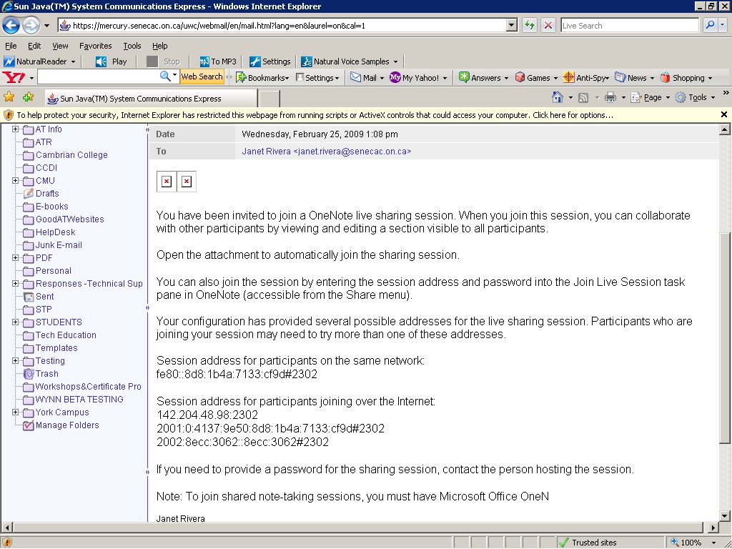
- Highlight and copy the information (IP address) from “Session address for participants joining over the internet..” section of the email. Do not copy all the text but just the IP address e.g. 142.204.48.98:2302

- Type the password provided (e.g. “Seneca”)

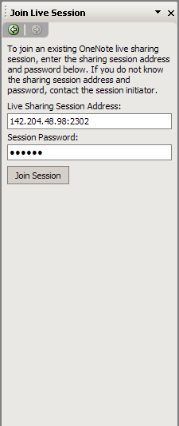
- Switch back to OneNote and go to Join Live Session window located at the right side of the screen
- Paste the IP address on “Live Sharing Session Address” field
- Type the Session Password

References:
Office OneNote Product Overview. Retrieved from http://office.microsoft.com/en-us/OneNote/HA101656661033.aspx on December 23, 2008.
All Things You Can Do with OneNote. Retrieved from http://office.microsoft.com/training/Training.aspx?AssetID=RP102640711033&CTT=6&Origin=RC102640561033 on December 23, 2008.
Covert, A. Livescribe Pulse Smartpen Digitally Copies Notes, Records 3D Audio. Retrieved from http://gizmodo.com/349511/livescribe-pulse-smartpen-digitally-copies-notes-records-3d-audio on February 19 2009.

